Q. WAP to connect to a website next page after login (filling EMP id and password.) With required field validator control
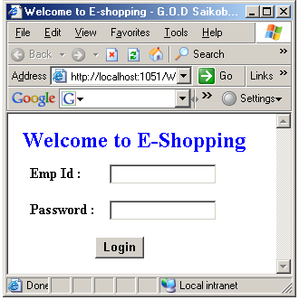

using System;
using System.Data;
using System.Configuration;
using System.Collections;
using System.Web;
using System.Web.Security;
using System.Web.UI;
using System.Web.UI.WebControls;
using System.Web.UI.WebControls.WebParts;
using System.Web.UI.HtmlControls;
using System.Data.SqlClient;

public partial class Default2 : System.Web.UI.Page
{
SqlConnection con;
SqlCommand cmd;
SqlDataReader dr;
string sqlstmt;

protected void Button1_Click(object sender, EventArgs e)
{
con = new SqlConnection("Integrated Security=SSPI;Persist Security Info=False;Initial Catalog=C#Prac;Data Source=.");
sqlstmt = "SELECT * FROM Emp WHERE Emp_Id='" + TextBox1.Text.ToString() + "' AND Pwd='" + TextBox2.Text.ToString() + "'";
cmd = new SqlCommand(sqlstmt, con);
con.Open();
dr = cmd.ExecuteReader();
if (dr.Read())
{
Response.Redirect("ValidEmp.aspx");
}
else
{
Response.Redirect("InValidEmp.aspx");
}

}

}

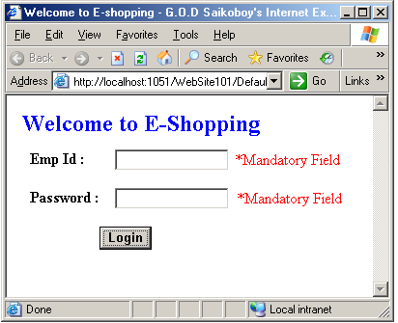

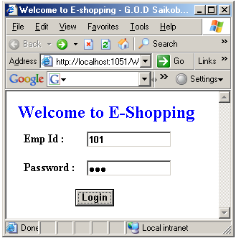

If Emp Id and Password are valid.


If Emp Id or Password is invalid or any field is blank.
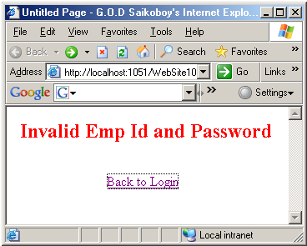

Q. WAP to save (i.e. INSERT) the student details into the student table with range validator control to check student age must be between 20 and 30 years.

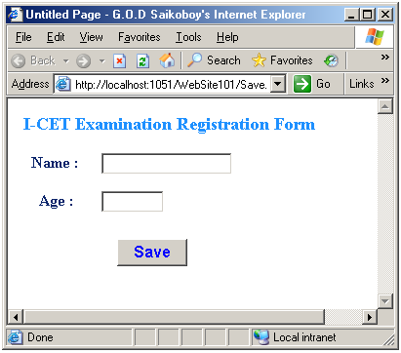

using System;
using System.Data;
using System.Configuration;
using System.Collections;
using System.Web;
using System.Web.Security;
using System.Web.UI;
using System.Web.UI.WebControls;
using System.Web.UI.WebControls.WebParts;
using System.Web.UI.HtmlControls;
using System.Data.SqlClient;

public partial class Save : System.Web.UI.Page
{
SqlConnection con;
SqlCommand cmd;
string sqlstmt;

protected void Button1_Click(object sender, EventArgs e)
{
con = new SqlConnection("Integrated Security=SSPI;Persist Security Info=False;Initial Catalog=C#Prac;Data Source=.");
sqlstmt = "INSERT INTO Stud(sname,age) VALUES('" + TextBox2.Text + "'," + TextBox3.Text + ")";
cmd = new SqlCommand(sqlstmt, con);
con.Open();
cmd.ExecuteNonQuery();
Response.Redirect("Saved.aspx");
TextBox2.Text = "";
TextBox3.Text = "";
}
}
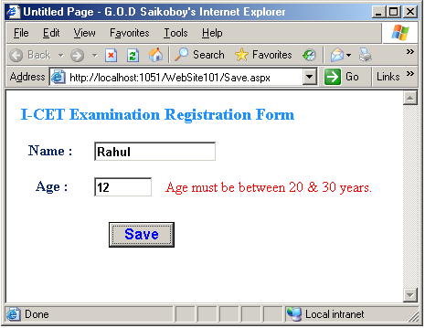
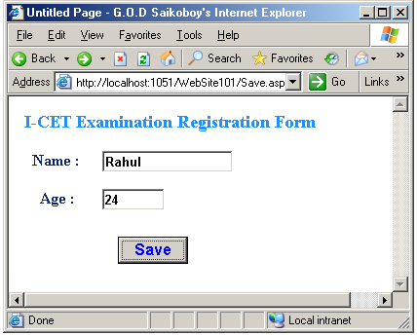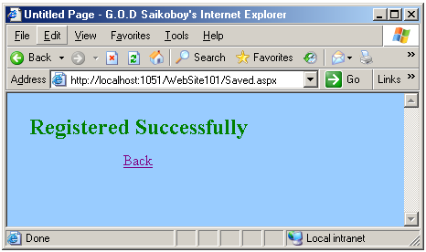

Q. WAP using compare validation control to check quantity should be greater than 50 pc.

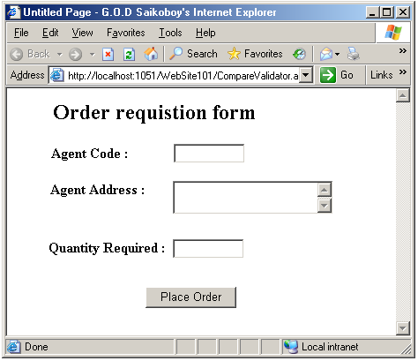

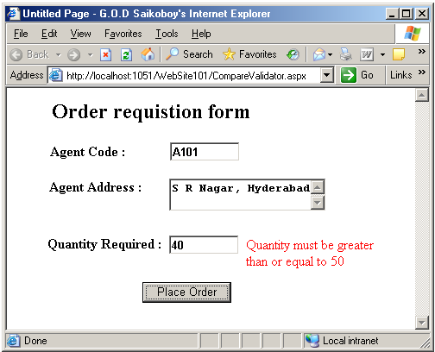

Q. WAP using Regular Expression validation control to check email id.
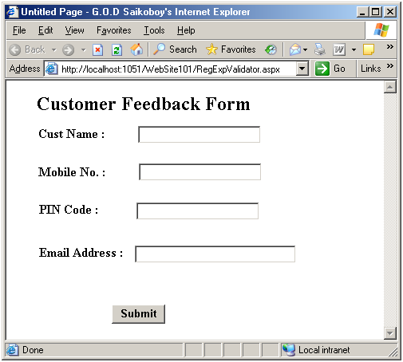

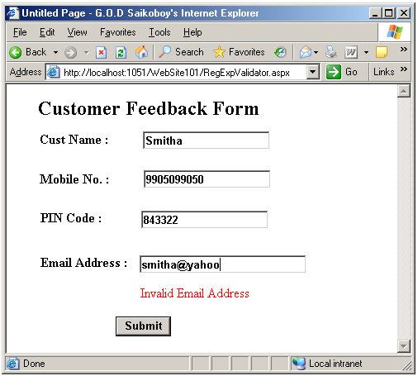

Q. WAP using Custom validator control to check quantity must be multiple of 10 before placing the order. .

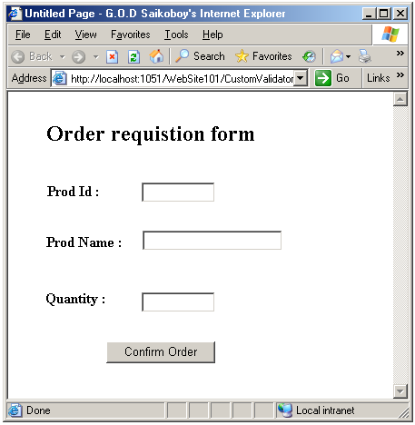

protected void CustomValidator1_ServerValidate(object source, ServerValidateEventArgs args)
{
if (int.Parse(args.Value) % 10 == 0)
args.IsValid = true;
else
args.IsValid = false;
}

